Project Proposal

My Project

Francis Igboeli, X15376391, francisx97@yahoo.ie

Degree Programme Name e.g. BSc (Hons) in Computing

Specialisation in Software Development

22/10/2018

# Objectives

The main object of my project is to have a platform where a landlord can manage his/her properties and to be able to communicate to their tenants. Some of the things that I have set out for the app to do are:

* For the landlord to be able to view property issues such as complaints in form of tickets sent by tenant.
* To display maintenance requirements such as boiler and gas and whether they need to be checked.
* To provide a page that displays services contacts such as plumbers’ contractors
* Details to insurance.
* A calendar where that bought tenant and landlord can view to schedule a property inspection.
* A place that keeps a record of work done to the property, payments made and any dealing between all parties.
* A place that enables you to pay your gas, heating and bin bills.
* A way for you to pay your rent as a tenant.
* List out other properties to buy from different landlords if they want to increase their ownership.

Those are the current objectives I have set out for the app to have. As I continue to build the app sure that some of those will be tweaked or I will decide to not implement them.

# Background

After being tasked to come up with a software project for my final year, I took to the internet find some ideas on what projects I could make that would get me a 1:1 grade. In order to achieve that grade I knew that the project would have to be challenging, it would have to be difficult and have some innovation to.

I found some ideas such as an augmented reality app that would be more suited for designers that allows you to take a picture on your phone and then the software would make a 3D model of the room you took a picture of. This project would have been an interesting prospect to do but it seemed too difficult to do. I have never ventured into VR before, so I was quite lost in that department. Then I stumbled across app idea for landlords and that peaked my interest.

I took a sudden interest to the project because I realised that I have yet to come across an application like that, that was primarily made for landlords instead they are more catered towards estate agents. This means landlords didn’t really have many options when it came to managing their properties they would have to manually keep their own paper records and ask their tenants to set up a direct deposit too.

I then decided what if there was a way that a landlord can have access to the same systems that estate agents have at there finger tips. The app would be easy for the them to access, bring a benefit to their lives and all in all make it easier for the on a day to day level.

I’ve also notice as a tenant, there isn’t much comminution between yourself and your landlord. We barely communicated with our landlord. We would mention that there was heating problem for example that it doesn’t seem to spread around the house and he would acknowledge it and then there would be no feedback for another week.

# Technical Approach

To develop this project, I will need to first research the requirements for the project. I have learned in past projects that setting clearly defined goals for the short and long-term are incredibly important for having a successful finished product. So before setting out to develop the product I will need to get the documentation for the project finished. This includes the project proposal, research requirements and specifications and the project plan. I will then begin creating my prototype.

For the case of literature review, I have found some apps on the Google Play store that I can view which will help me figure out what more that I need in order to make the app feel different to what is already out there. I have also seen some software that can be download to your pc with similar functionality to what I have in mind.

There will be periods through out the project where I have to gain more knowledge in some areas that will be beneficial to my projects in my implementation stage. I have found database software to use hopefully one with a cloud connection. I think they best option for me to go with is Google Firebase. Firebase has a lot of functionalities, easy to implement with the project and free.

I have also decided the take an iterative methodology approach with this project. I will first set out my targets and then go with flow. I will make the design and code the app. Then debug and perform my tests. Then I can set up Survey to further help flesh the app.

# Project Plan

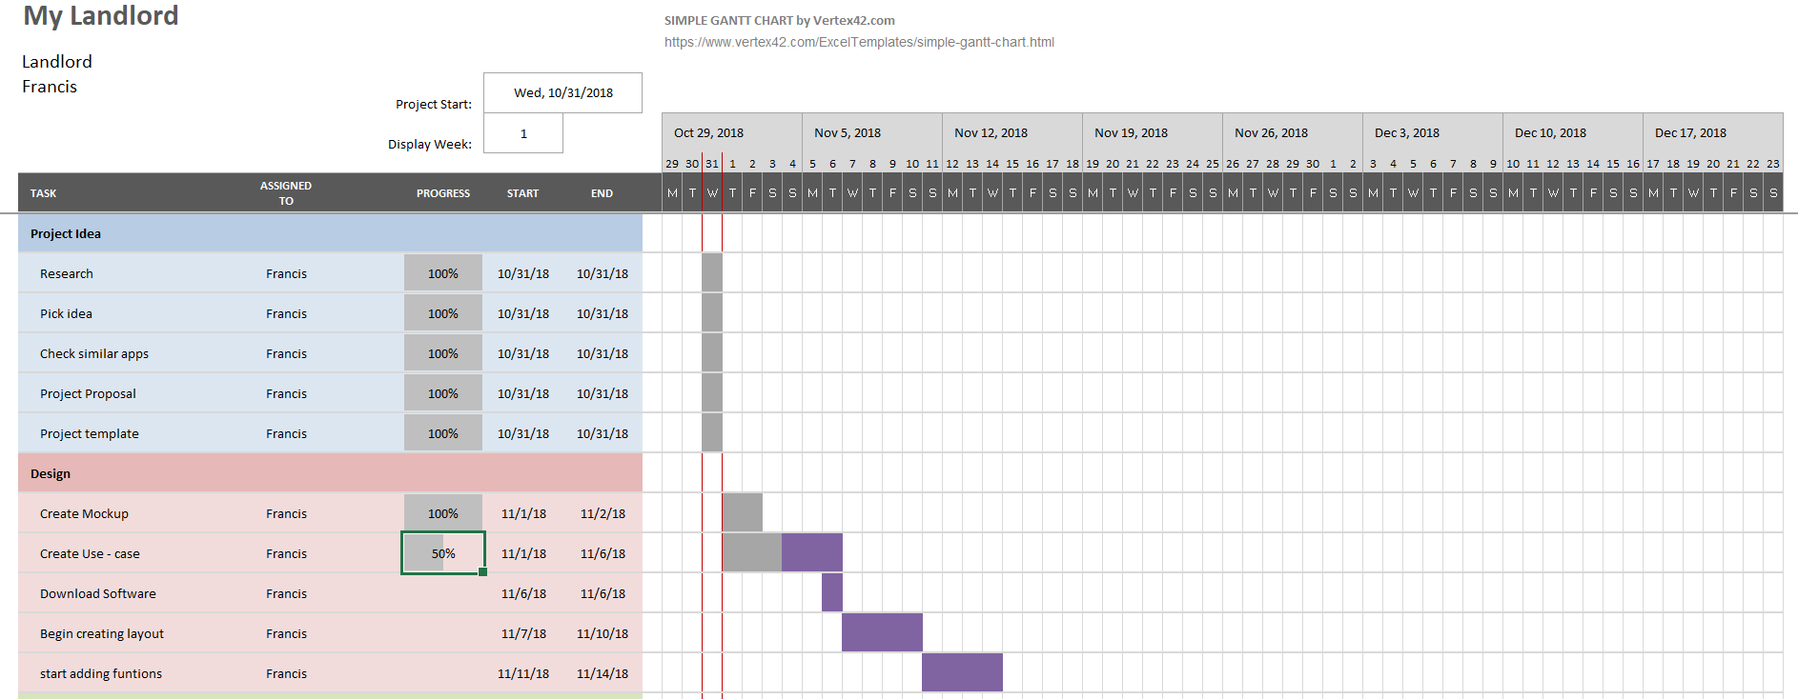

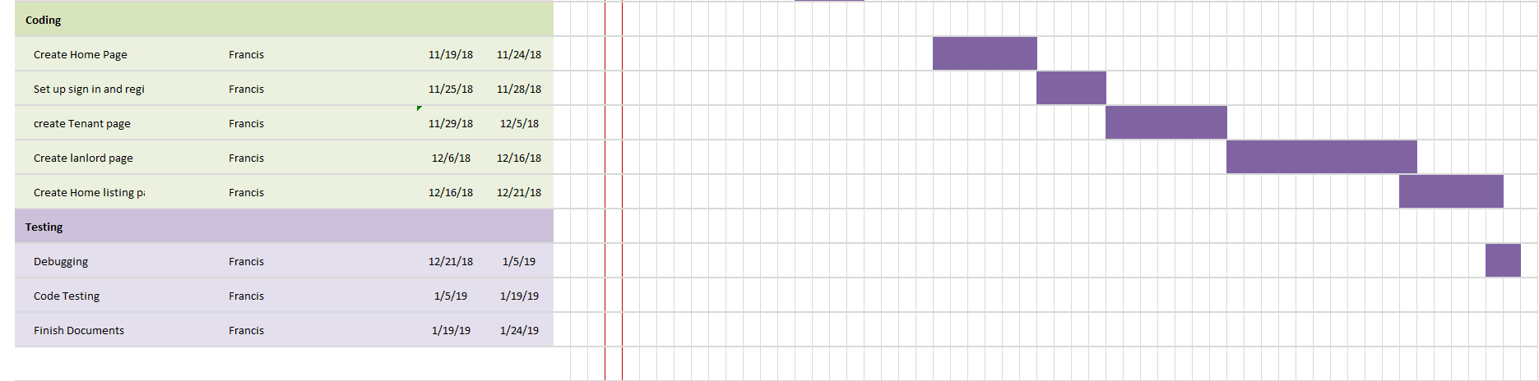

# Technical Details

Implementation language and principal libraries

* Android Studio – this will be the primary platform where all my code will be written. It will help me create an emulator with my phone where I can truly test the app and see what it actually feels like when being held.
* Firebase – this will be use as my cloud storage for most data on acquired during the lifecycle of the project.

Languages that I will be using Include:

* Java,
* HTML
* CSS
* XML
* PHP

# Evaluation

Just like in any project undertaken, testing is an unbelievably important part of the process. Without testing an incomplete, faulty or inaccurate project can be completed. Therefore, at various stages throughout the project I will be testing and re-testing my work and my findings. In completion of all the tests and of the project.

I will be running different types of testing during the testing stage of the project:

Unit testing, Integration testing, System testing and Acceptance Testing.